Fisherford Primary School

Welcome to Primary 1

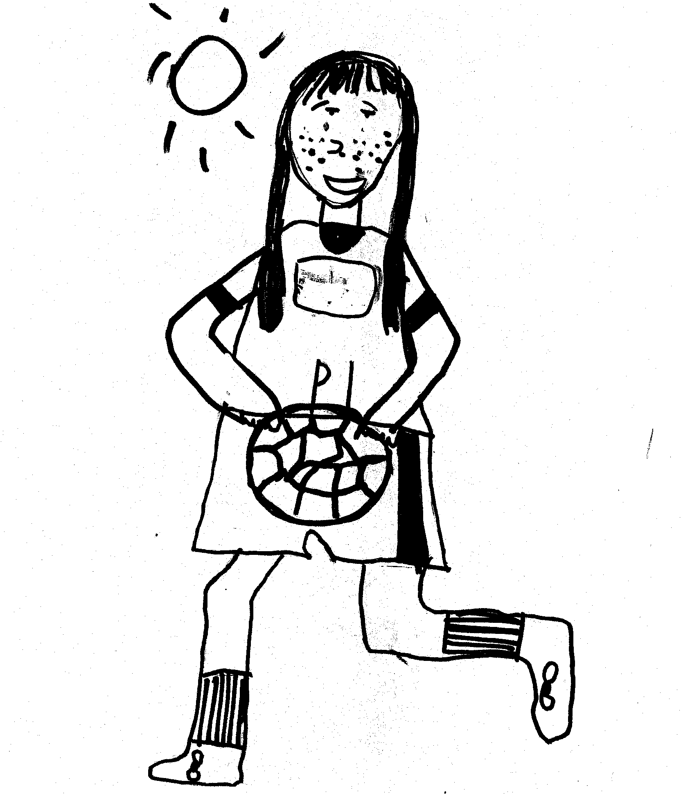

Fisherford School
COMING IN TO PRIMARY 1

Most children have been to playgroup or nursery but starting school is still a big step.

In this booklet we deal with some practical issues as well as how you can help prepare your child for school.

Our aim is to provide a happy, healthy, safe and stimulating environment and activities to give your child the best possible start to school life.
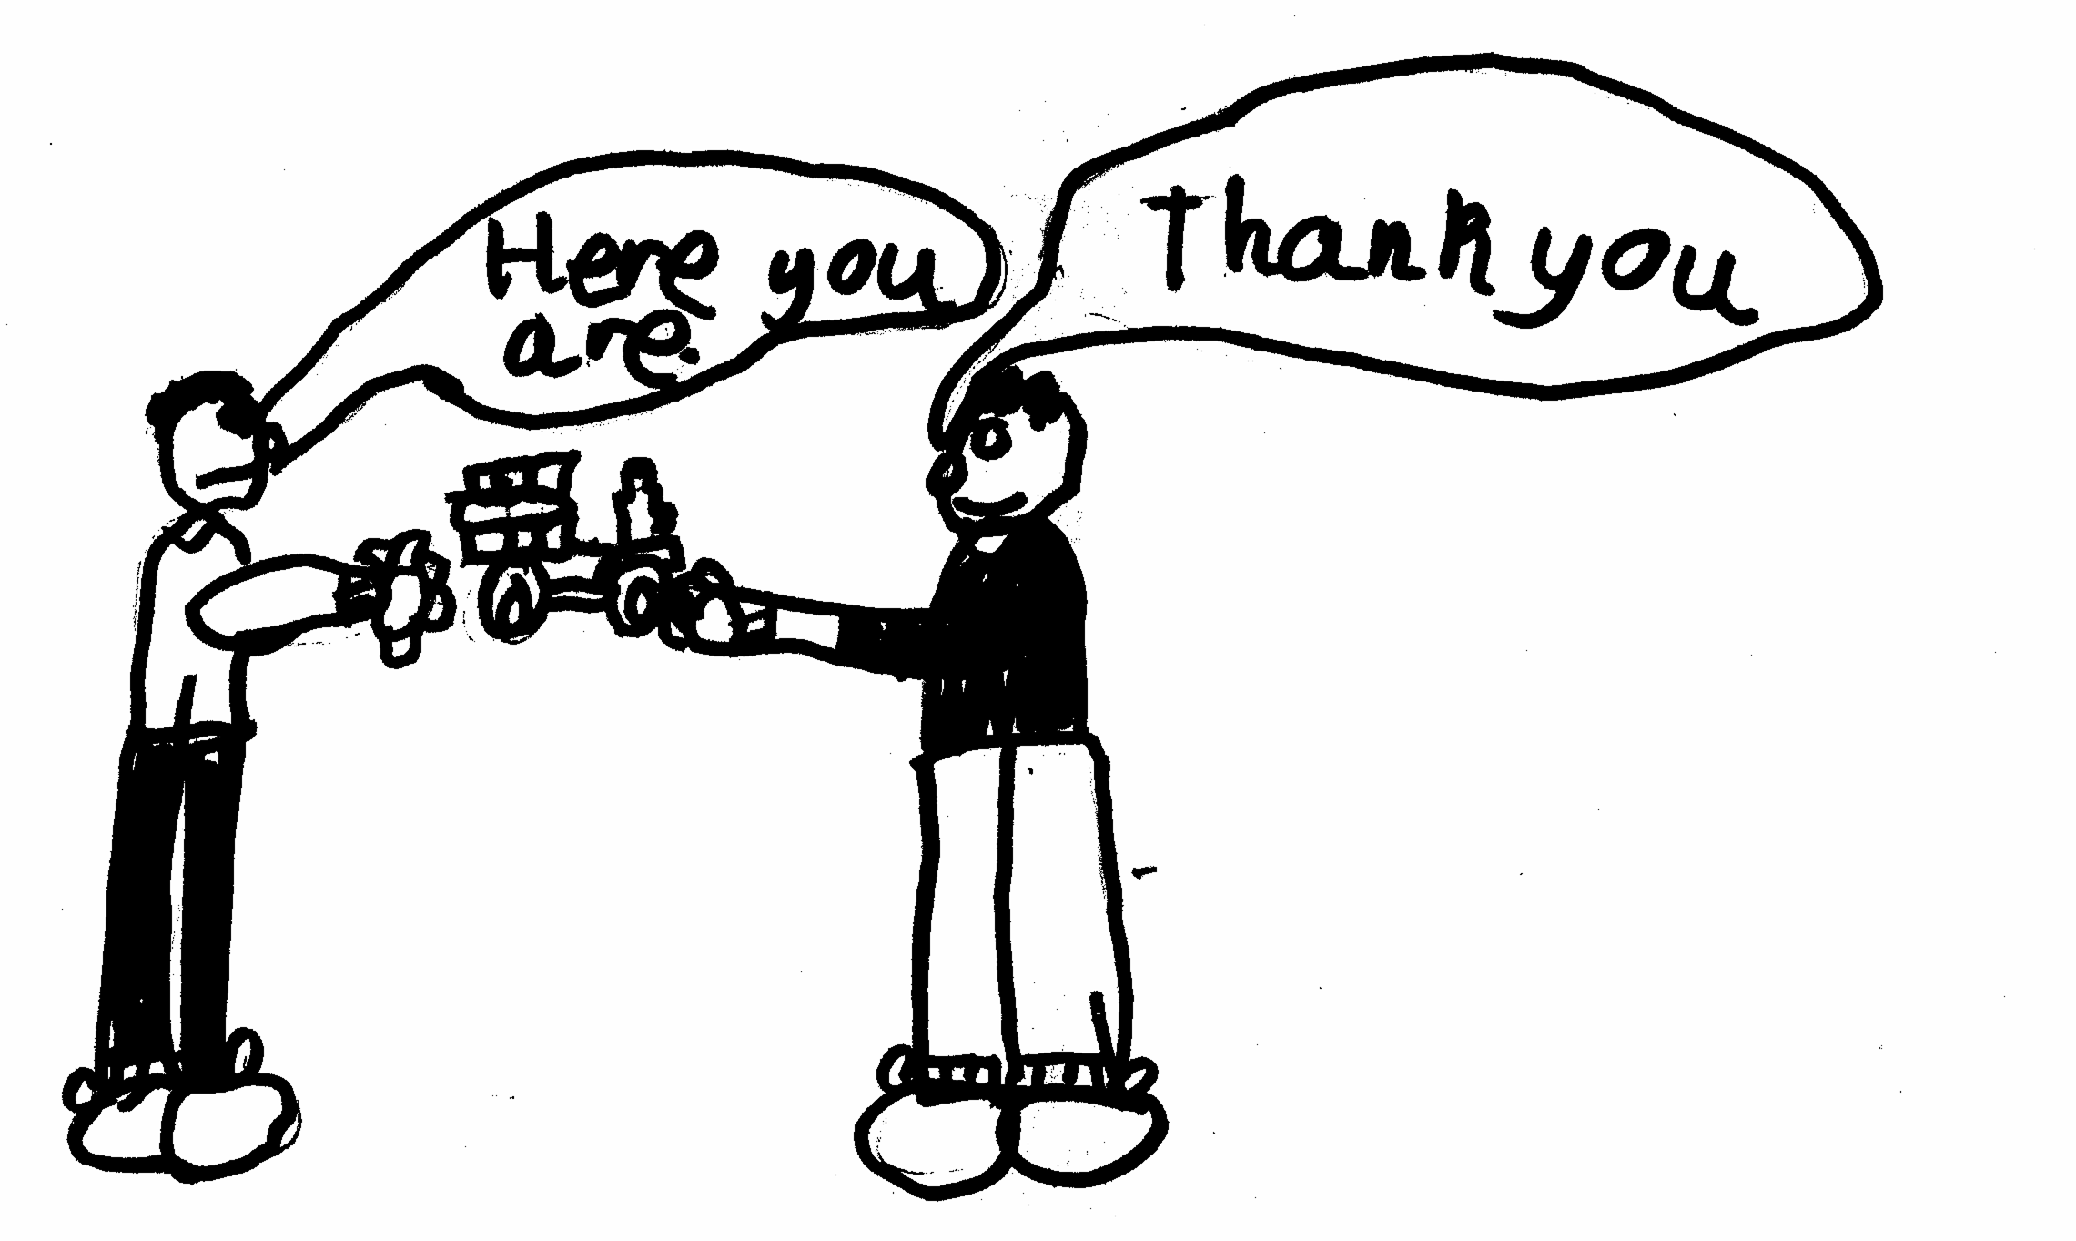

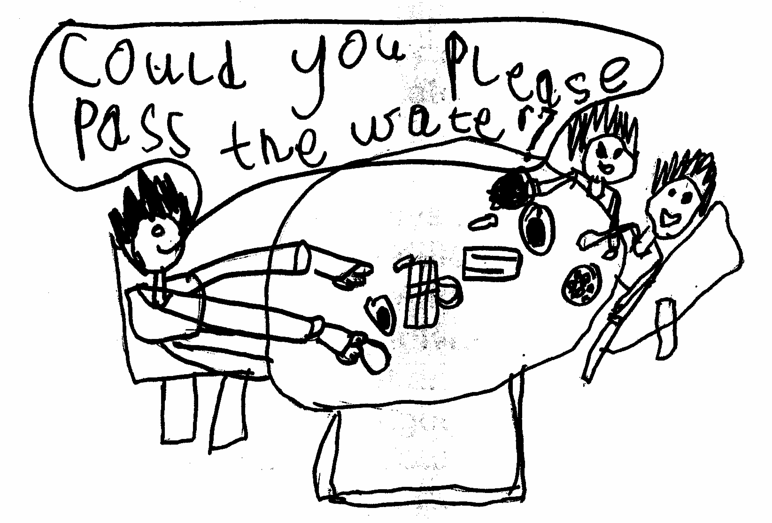

SOME PRACTICAL HINTS

Please put names on everything; clothes, shoes, bags etc.

Children often like to bring toys – again a name or identification mark would be a great help. However, we have to say that toys are the responsibility of the individual child and the school is not liable for any toys that are lost or damaged.
Please note at the moment NO TOYS/ PENCIL CASES etc are allowed to be brought to school due to Covid-19 restrictions.

We encourage all pupils to wear our school uniform. This helps to instill a sense of belonging and team spirit within our school. Pupils, parents and staff were involved in choosing the current dress code and the items have been selected so that pupils clearly identify with the school. School Uniform is available to order online at http://www.pomprintdesigns.com/
School uniform consists of - school sweatshirt and yellow polo shirt with school logo, dark school skirt or trousers, dark school shoes (children should not wear high heeled shoes as these cause safety concerns). Children bring a pair of soft indoor shoes to keep at school and to wear inside the building. We appreciate your cooperation in support of this.

PE Kit consists of – T shirt which tucks into shorts, standard length shorts, socks, gym shoes (preferably with Velcro or elastic fastening for younger pupils) all kept in a gym bag. (At present, pupils are asked to come to school already wearing PE kit on gym days, this is in line with advice on infection prevention).

Each child needs an overall for the “messy bits” – an old shirt is ideal or apron is ideal. Indoor shoes / gym shoes are needed for classroom use. These are kept at school.

Pupils do 2 hours of PE / Active Health per week. For this they need to come to school already wearing sports kit. We will let you know which days our PE lessons will be. For safety reasons, if your child wears earrings, they need to be taped over or removed for gym activities.

Many children find tying laces difficult when they come to school at first, so would you please give some thought to the alternative fastenings available. It helps the child to be more independent.

If children travel to school on the bus they should sit quietly with their seat belt on. The seat belts should not be undone until the bus stops. At the moment, all pupils are asked to wear a face covering on school transport.

Also, for safety reasons, pupils should stay in the playground at all times during break or lunchtime. It is quite a busy road out there!

We follow the Golden Rules.

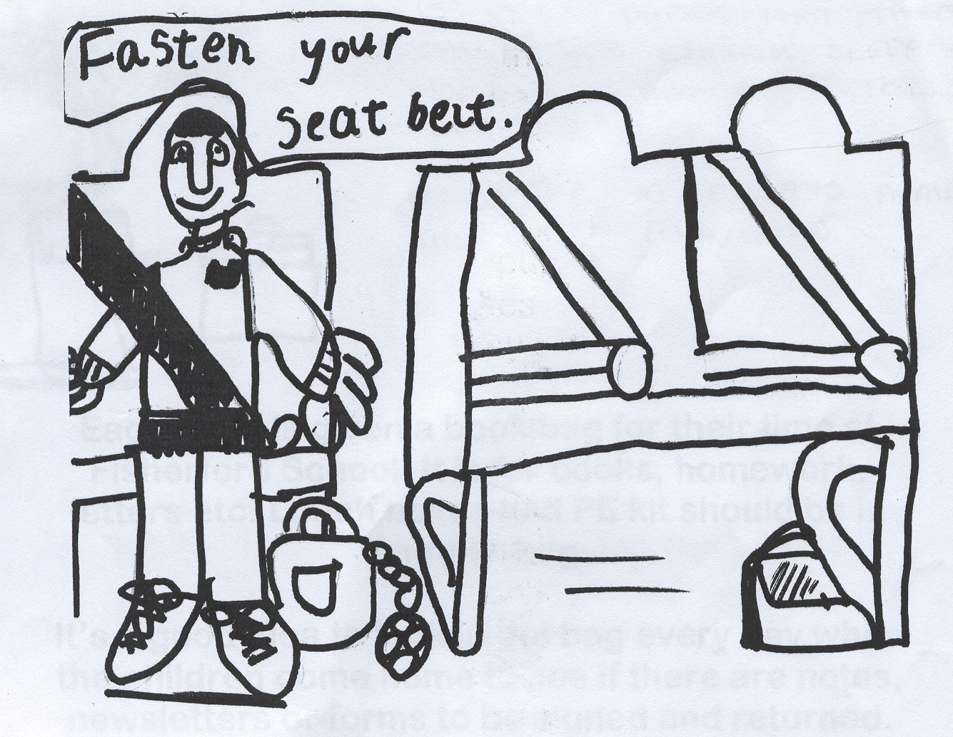
They are:
- DO BE GENTLE
- DO BE KIND AND HELPFUL
- DO WORK HARD
- DO LOOK AFTER PROPERTY
- DO LISTEN TO PEOPLE
- DO BE HONEST

A healthy school lunch is available free of charge for pupils in P1-P3. If you prefer, your child may bring a healthy packed lunch to school, please try to avoid sweets and foods high in sugar. We do not allow cans of fizzy juice for lunchtime.

If your child has a cold, please put a handkerchief or tissues in the bag as the school does not provide them. If they are really feeling unwell, please keep them at home where they will be more comfortable. If your child has any symptoms of Covid-19, a temperature, cough, sickness, sore throat etc, please do not send him/her to school. We would prefer that any medicine is administered at home but if it needs to be given in school time, you will be asked to complete the appropriate permission forms.

It is very important that your child gets enough sleep to have enough stamina to follow the school day. Each day is very busy and your child my seem tired by the end of the week. Children also often come home from school feeling hungry, this is normal, even though they have eaten a good lunch.

Cold water is always available for your child to drink and your child needs to bring a water bottle from home. This should be returned home to be washed every day. We do not allow diluted/ sparkling juice in the water bottles at school.

Each pupil is given a book bag for their time at Fisherford Primary School. It is for books, homework, letters etc. Lunch boxes should be in another bag.

It is a good idea to look in the bag every day when the children come home to see if there are notes, newsletters or forms to be signed and returned. There may also be homework to do.

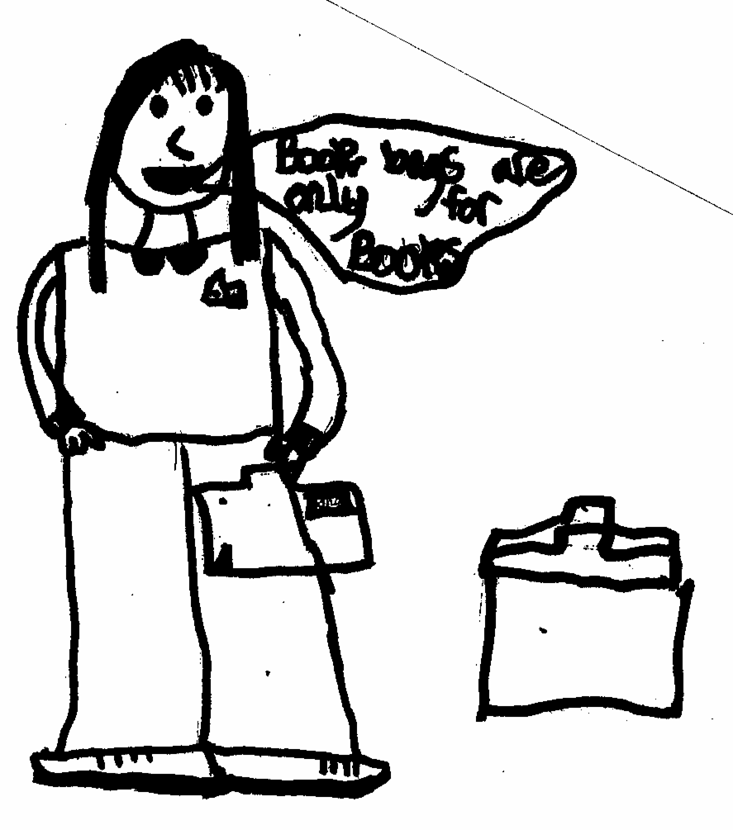

HOW YOU CAN HELP

Encourage your child to be as independent as possible – dress / undress, go to the toilet and flush it, wash hands, blow nose, cope with eating on their own, using cutlery etc.

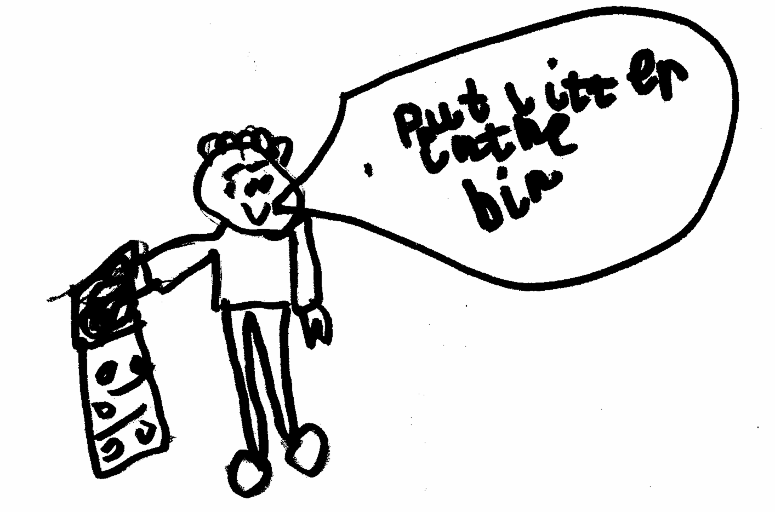

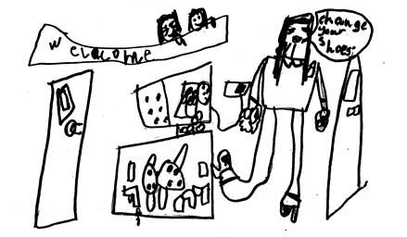

At home, please read stories to your child, say nursery rhymes, look at picture books, do puzzles in magazines, cut out and although it may drive you crazy at times, encourage them to question and talk about things.

These are important activities that lead onto reading and writing.

In Primary 1 we do lots of phonics (sounds)
You can help by playing lots of games like I SPY.
E.g. I spy something beginning with a (as in apple)
Not A (as in aeroplane)

We also do lots of learning through developmental play.
Your child will have some initial screening sessions during the first few weeks of the term, so that the teacher can assess his/ her learning needs. We are a very small school and this means we can tailor learning experiences for each individual.

Children love to write and please encourage them.

If they are writing their name please only use a capital letter at the beginning.

E.g. John Not JOHN

At home, encourage them to use everyday objects e.g. buttons, toy cars for sorting, grouping according to size, shape or colour.

Visits almost anywhere – the park, the beach can provide many opportunities for children to increase their understanding of measurement in relation to time, distance, size and shape. A visit to the park can also encourage and develop the importance of being active.

A trip to the supermarket or local shops not only will involve other mathematical aspects such as money and information handling but could also encourage making healthy food choices.

Parents are always very welcome but if there is something you want to discuss it would be better before we start in the morning or after we finish in the afternoon. At the present time we are not able to welcome parents into the building as we usually would, due to Covid-19 restrictions. You are welcome to phone or email.

We hope that together we can make your introduction to school a happy one. We will offer your child a few ‘stay and play’ sessions, during May/June (depending on the Covid-19 situation) and also the opportunity to try a school lunch.

Please feel able to ask questions and to raise any concerns which you or your child may have. Sometimes changing a small thing can make all the difference to your child feeling settled and happy, but if we don’t know about it, we can’t help.

We look forward to meeting you.



